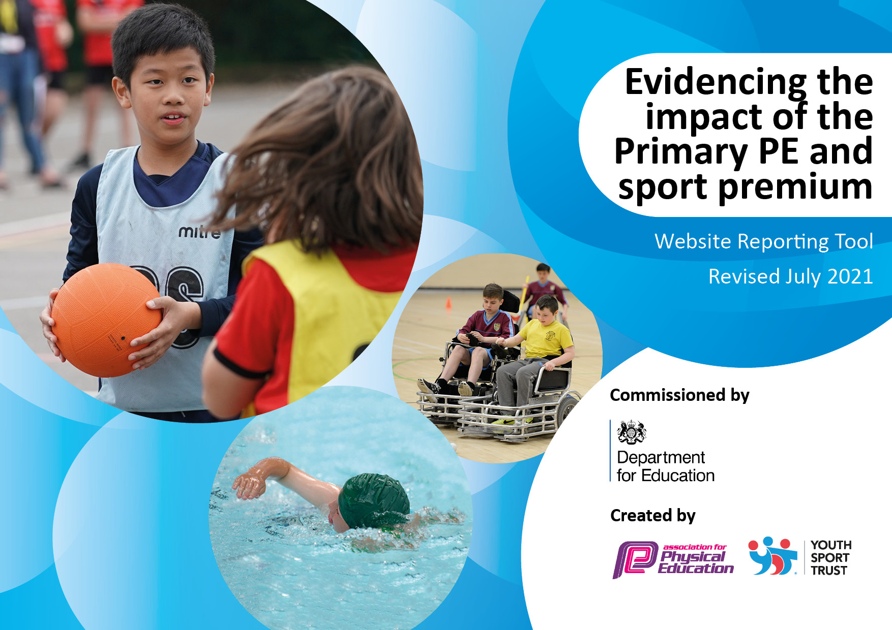
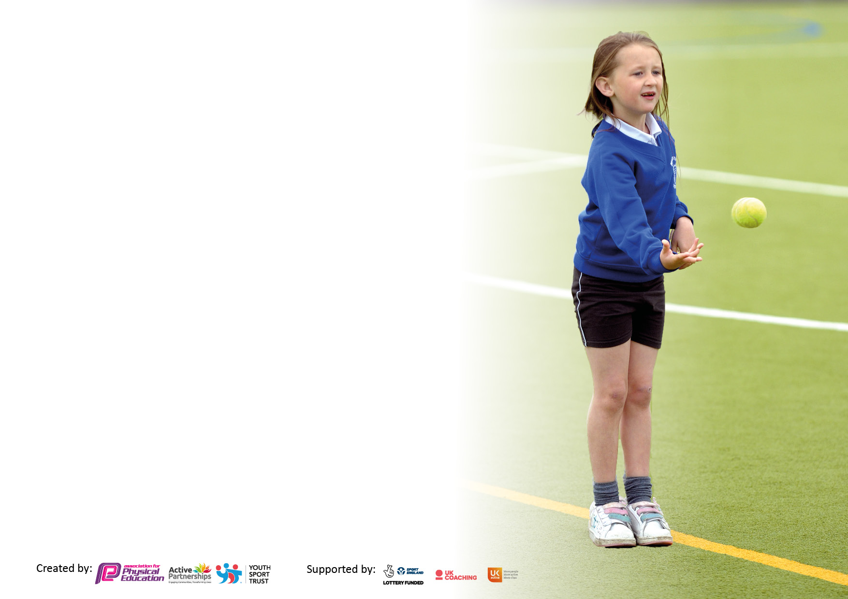

It is important that your grant is used effectively and based on school need. The Education Inspection Framework makes clear there will be a focus on ‘whether leaders and those responsible for governors all understand their respective roles and perform these in a way that enhances the effectiveness of the school’.

Under the Quality of Education Ofsted inspectors consider:
Intent - Curriculum design, coverage and appropriateness
Implementation - Curriculum delivery, Teaching (pedagogy) and Assessment
Impact - Attainment and progress

To assist schools with common transferable language this template has been developed to utilise the same three headings which should make your plans easily transferable between working documents.

Schools must use the funding to make additional and sustainable improvements to the quality of Physical Education, School Sport and Physical Activity (PESSPA) they offer. This means that you should use the Primary PE and sport premium to:

- Develop or add to the PESSPA activities that your school already offer
- Build capacity and capability within the school to ensure that improvements made now will benefit pupils joining the school in future years
- The Primary PE and sport premium should not be used to fund capital spend projects; the school’s budget should fund these.

Pleasevisitgov.ukfortherevisedDfEguidanceincludingthe5keyindicatorsacrosswhichschoolsshoulddemonstrate animprovement.Thisdocumentwillhelpyoutoreviewyourprovisionandtoreportyourspend.DfEencouragesschools to use this template as an effective way of meeting the reporting requirements of the Primary PE and sport premium.

We recommend you start by reflecting on the impact of current provision and reviewing the previous spend.

Schools are required to publish details of how they spend this funding, including any under-spend from 2019/2020, as well as on the impact it has on pupils’ PE and sport participation and attainment. All funding must be spent by 31st July 2022.

We recommend regularly updating the table and publishing it on your website throughout the year. This evidences your ongoing self-evaluation of how you are using the funding to secure maximum, sustainable impact. Final copy must be posted on your website by the end of the academic year and no later than the 31st July 2021. To see an example of how to complete the table please click HERE.
Created by: Supported by:

Details with regard to funding
Please complete the table below.

Total amount carried over from 2019/20 | £0
Total amount allocated for 2020/21 | ££16,364
How much (if any) do you intend to carry over from this total fund into 2021/22? | ££9664- not spend due to Covid restrictions- no swimming or transport costs, also no forest school for the Summer, or Spring term, no transport costs for competitions.
Total amount allocated for 2021/22 | £9500
Total amount of funding for 2021/22. To be spent and reported on by 31st July 2022. | £25,961
Swimming Data
Please report on your Swimming Data below.

Meeting national curriculum requirements for swimming and water safety.

N.B. Complete this section to your best ability. For example you might have practised safe self-rescue techniques on dry land which you can then transfer to the pool when school swimming restarts.
Due to exceptional circumstances priority should be given to ensuring that pupils can perform safe self rescue even if they do not fully meet the first two requirements of the NC programme of study
What percentage of your current Year 6 cohort swim competently, confidently and proficiently over a distance of at least 25 metres?  N.B. Even though your pupils may swim in another year please report on their attainment on leaving primary school at the end of the summer term 2020.  Please see note above | 86%
What percentage of your current Year 6 cohort use a range of strokes effectively [for example, front crawl, backstroke and breaststroke]?  Please see note above | 86%
What percentage of your current Year 6 cohort perform safe self-rescue in different water-based situations? | %
Schools can choose to use the Primary PE and sport premium to provide additional provision for swimming but this must be for activity over and above the national curriculum requirements. Have you used it in this way? | Yes/No

Action Plan and Budget Tracking
Capture your intended annual spend against the 5 key indicators. Clarify the success criteria and evidence of impact that you intend to measure to evaluate for pupils today and for the future.

Academic Year: 2020/21 | Total fund allocated: | Date Updated:
Key indicator 1: The engagement of all pupils in regular physical activity – Chief Medical Officers guidelines recommend that primary school pupils undertake at least 30 minutes of physical activity a day in school |  |  |  | Percentage of total allocation:
 |  |  |  | %
Intent | Implementation |  | Impact
Your school focus should be clear what you want the pupils to know and be able to do and about  what they need to learn and to  consolidate through practice: | Make sure your actions to achieve are linked to your intentions: | Funding allocated: | Evidence of impact: what do pupils now know and what can they now do? What has changed?: | Sustainability and suggested next steps:
2 hours of timetabled lessons each week for every pupil, allowing pupils to develop themselves as a whole person, build a sound knowledge of basic skills and to build a positive relationship with physical health.  Children develop a love for the local environment.  All children to become proficient swimmers.  All children to participate in 1km per day. | All staff will have access to a bank of structured lessons. Each lesson has a social, personal and technical objective, ensuring that the whole person is developed throughout. Staff use cross curricular links and brain breaks to ensure children are active at some point in most lessons.  Use of coaches from Allerdale Sports Partnerships.  Children are encouraged to participate in extra-curricular activities.  Continue to implement the Jigsaw scheme across the school.  All children in KS2 to have swimming lessons from year 3-6.  Children will attend forest school sessions.  Children will be given opportunity to participate 1km per day. | £3800  £7,372  £2520 | Children will become more active each day. Improving their health and wellbeing.  Children will be aware of the benefits of physical activity.  Children will have a good knowledge of basic skills. | Shred knowledge between staff from observing coaches in the Allerdale Sports Partnership.  Jigsaw to be used throughout the school.  Time is allocated for children to complete the 1km per day
Key indicator 2: The profile of PESSPA being raised across the school as a tool for whole school improvement |  |  |  | Percentage of total allocation:
 |  |  |  | %
Intent | Implementation |  | Impact
Your school focus should be clear what you want the pupils to know and be able to do and about  what they need to learn and to  consolidate through practice: | Make sure your actions to achieve are linked to your intentions: | Funding allocated: | Evidence of impact: what do pupils now know and what can they now do? What has changed?: | Sustainability and suggested next steps:
To celebrate achievements by children in PE.  To introduce a PE display board with in school to share events, information and to celebrate sporting achievements.  Inspire children to participate in PE.  To advertise sports clubs in the local area. | To introduce certificates for children to celebrate the School Games values- determination, honesty, passion, respect, self-belief, and teamwork.  Organise an athlete visit.  Play leaders.  Pupil voice. | £180 |  | Time given to staff to update PE board.  Establish Good links with local sports Clubs.  Pupils’ voice.

Key indicator 3: Increased confidence, knowledge and skills of all staff in teaching PE and sport |  |  |  | Percentage of total allocation:
 |  |  |  | %
Intent | Implementation |  | Impact
Your school focus should be clear | Make sure your actions to | Funding | Evidence of impact: what do | Sustainability and suggested
what you want the pupils to know | achieve are linked to your | allocated: | pupils now know and what | next steps:
and be able to do and about | intentions: |  | can they now do? What has
what they need to learn and to |  |  | changed?:
consolidate through practice:
Staff will gain knowledge of core sports and multi skills.  Staff will be confident to support children with their well-being and mental health.  Staff implement active minutes throughout all areas of the curriculum, using the outside space. | The use of Allerdale sports partnership. Staff will assist specialist coaches and share knowledge with staff.  N.Robinson to attend cluster meetings within the Sports partnership and cluster.  N. Robinson share knowledge of CPD on gymnastics.  Staff will continue to follow the jigsaw programme within school.  N. Robinson is a trained Mental Health first aider- N.Robinson shared knowledge with all staff.  N. Robinson attended Active Start for KS1. | £675 | Staff will become confident delivering PE lessons and accompanying children to competitions.  Staff will feel confident to support children.  Children will feel confident to talk to staff in school. | Staff will share knowledge from observing Allerdale Sports coaches.  Share good practice with schools in the cluster.  Jigsaw to continue throughout the school.
Key indicator 4: Broader experience of a range of sports and activities offered to all pupils |  |  |  | Percentage of total allocation:
Intent | Implementation |  | Impact
Your school focus should be clear | Make sure your actions to | Funding | Evidence of impact: what do | Sustainability and suggested
what you want the pupils to know | achieve are linked to your | allocated: | pupils now know and what | next steps:
and be able to do and about | intentions: |  | can they now do? What has
what they need to learn and to |  |  | changed?:
consolidate through practice:
To improve Gymnastic provision, particularly at KS2.  To offer opportunities to children of all circumstances to enjoy clubs and initiatives outside of school hours - allowing pupils to develop themselves as a whole person, build a sound knowledge of basic skills and build a positive relationship with physical health.  Children will develop broader skills of climbing, swinging, lifting, team work, and collaboration.  Swimming- All children in KS2 to participate in swimming lessons.  Orienteering- children in KS2 will have the opportunity to attend an Orienteering club out of school.  To expose children to multi discipline events.  Additional achievements: | To make use of the school hall and the village hall and reintroduce sessions at Beacon Hill.  To buy additional resources.  N. Robinson to attend CPD- British Gymnastics online.  To increase the after school club activities on offer.  To develop our lunch time provision to train older children to deliver games.  To actively encourage the children to join in local teams and activities outside of the school environment.  All children will attend a block of sessions in the forest.  Children will attend Wigton swimming pool.  Children in KS2 will have the opportunity to participate in triathlon and duathlon events. | £180 | To raise the standard of gymnastics at Plumbland School. Look at possible competitions to enter with children.  To maintain and increase the level of attendance at afterschool clubs and to vary the activities available following pupil/parent voice feedback.  Children will have the confidence to join local teams and develop their skills out of school.  Children will develop gross motor skills in the forest environment.  Children will become able swimmers.  Children will be exposed to multi discipline activities. | Arrange gymnastic sessions at Beacon Hill.  Complete training and CPD online.  To advertise local sports teams.  Reintroduction of Sports Leaders.  A new member of staff has been employed to continue the forest school provision.  Lessons have been booked for swimming throughout the year and going into 2023.  An orienteering specialist is part of our staff team to deliver sessions and CPD.

Key indicator 5: Increased participation in competitive sport |  |  |  | Percentage of total allocation:
 |  |  |  | %
Intent | Implementation |  | Impact
Your school focus should be clear | Make sure your actions to | Funding | Evidence of impact: what do | Sustainability and suggested
what you want the pupils to know | achieve are linked to your | allocated: | pupils now know and what | next steps:
and be able to do and about | intentions: |  | can they now do? What has
what they need to learn and to |  |  | changed?:
consolidate through practice:
To give children an opportunity to develop a better sense of competition - either competing against themselves, others in a recognised environment (PE lessons for example) or against an unrecognised opponent. Increased exposure to competition will allow pupils to better develop their relationship with physical health and its ability to build traits such as humility, cooperation, passion, pride and competitiveness. | Staff will plan opportunities for children to use newly acquired skills in competitive games/activities during PE lessons.  We will host a variety of tournaments at school both inter and intra.  We will attend at least one tournament per term half term.  Children will get opportunity to represent their school.  Expose children to real life athletes to inspire children to join in with sports. | £400 | Children will work as part of a team.  Children will represent their school  Children will compete in a inter/intra competition in the disciplines.  Term 1: Rugby  Term 2: Football  Term 3:Cross country  Term 4: Orienteering and Netball  Term 5: Rounders and multi skills  Term 6: Athletics

Signed off by
Head Teacher: | C McKie
Date: | 31.3.22.
Subject Leader: | N Robinson
Date: | 31.3.22.
Governor: | J Taylor
Date: | 31.3.22.

